**Co-Pilot: helps visually impaired people**

**to navigate in their daily life**

**THESIS SUBMITTED IN PARTIAL FULFILLMENT OF THE REQUIREMENT FOR THE AWARD OF THE DEGREE OF**

**ROBOTICS AND AUTOMATION**

SUBMITTED BY

**Aditya Pandey**

**Samradny Ware**



**Under the Guidance of Dr. Satish Kumar**

## SYMBIOSIS INSTITUTE OF TECHNOLOGY

## YEAR 2022-26

**CONTENTS**

|  | Page No. |
| --- | --- |
| **Abstract** | 2 |
| **Introduction** | **4** |
| **Literature Review** | 6 |
| **Methodology** | 13 |
| **Results and Discussions** | 20 |
| **Bibliography** | 21 |
|  |  |

# Abstract

This initiative tackles a pressing issue faced by those with visual impairments: the challenge of limited independence and mobility. Through the groundbreaking capabilities of deep learning and transfer learning, we introduce an advanced solution embodied in computer vision-driven smart glasses. These glasses aim to empower visually impaired individuals, granting them enhanced confidence and autonomy in navigating their surroundings. Our endeavor, titled "Vision-Powered Smart Glasses," revolves around the creation of cutting-edge eyewear embedded with state-of-the-art computer vision technology. These smart glasses seamlessly integrate deep learning and transfer learning methodologies, allowing them to comprehend and interact with the visual world in real time.

At the core of this project lies the development of sophisticated deep neural networks tailored for object detection, recognition, and scene analysis. These networks undergo rigorous training and fine-tuning through transfer learning on extensive datasets, enabling the glasses to identify objects, decipher text, navigate obstacles, and furnish the user with context-aware information. To intuitively convey this information, the smart glasses utilize sensory feedback mechanisms, including auditory and haptic cues.

The user interface has been meticulously crafted to meet the specific needs of visually impaired individuals. Voice commands, gestures, and tactile inputs facilitate a seamless interaction with the smart glasses. Additionally, the integration with navigation and wayfinding systems, alongside geospatial services, ensures users can confidently and independently traverse both indoor and outdoor environments.

By deploying these computer vision-powered smart glasses, our goal is to deliver a practical and innovative tool that not only addresses challenges but also enhances the lives of users, offering them greater freedom and the opportunity to explore the world on their own terms.

**Introduction**

## **Introduction to Machine Learning and Deep Learning**

Machine Learning (ML) and Deep Learning (DL) are subfields of artificial intelligence (AI) that focus on the development of algorithms and models that enable computers to learn and make decisions from data without being explicitly programmed.

Machine Learning is a broader field that encompasses a variety of techniques and algorithms designed to enable computers to improve their performance on a specific task as they are exposed to more data.Deep Learning is a subset of Machine Learning that focuses on neural networks with many layers (deep neural networks). These networks are inspired by the structure and function of the human brain and are designed to automatically learn and extract hierarchical features from data.In summary, while Machine Learning is a broader field that encompasses various learning techniques, Deep Learning is a specific subset of Machine Learning that focuses on deep neural networks and has played a pivotal role in the recent advancements of artificial intelligence.

## Working Mechanism of Smart Glasses using Vision sensor

Creating smart glasses that leverage a vision sensor and incorporate deep learning, including transfer learning, involves a multifaceted approach. The core components and mechanism include a vision sensor, data collection, preprocessing, deep learning models, transfer learning, real-time inference, display and user interface, connectivity, power management, user feedback, and privacy and security.

The smart glasses are equipped with a vision sensor, such as a camera, capturing data from the environment. These data streams are subjected to preprocessing, encompassing noise reduction, image stabilization, and color correction. Deep learning models play a pivotal role in interpreting this visual data. Object detection models like R-CNN or Faster R-CNN are employed to identify objects in the environment. Transfer learning fine-tunes these models for specific tasks. Semantic segmentation models like U-Net or DeepLabv3 provide a detailed understanding of the scene. Facial recognition models like OpenFace or FaceNet can also be integrated and fine-tuned.

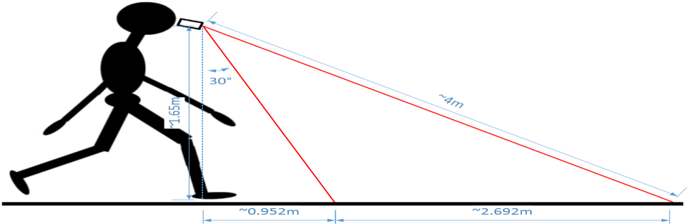

Fig.1.2.1 Depth Information Acquisition

In real-time, the models make predictions based on the data, which are then displayed on the smart glasses' screen, offering users relevant information about their surroundings. A user interface, typically voice-activated or gesture-based, allows interaction with the glasses. Connectivity to the internet or other devices is essential for extended functionality. Power management is crucial for prolonged usage, while continuous user feedback and model updates enhance the user experience.

Moreover, addressing privacy and security concerns is imperative. Data processing and storage should be secure, and users must retain control over their data. Creating such smart glasses is an interdisciplinary effort that combines expertise in computer vision, sensor technology, deep learning, and user experience design. It requires careful consideration of user needs, an iterative development process, and a robust framework for privacy and security

# Literature review

## Computer vision in automation

In recent years, there has been a growing interest in the application of machine vision technology in industrial production lines. According to Baygin and Karakose (2017), machine vision systems can be used to perform a range of processes, including product counting, defect **identification**, and dimension measuring, without the need for specialized control. These systems employ cameras that allow for quick, seamless, and accurate measurements, thereby increasing production capacity and enabling the delivery of finished goods to the customer. As technology continues to advance, machine vision systems are becoming more accessible to all production facilities, thanks to the development of measuring technology that can operate at high rates.

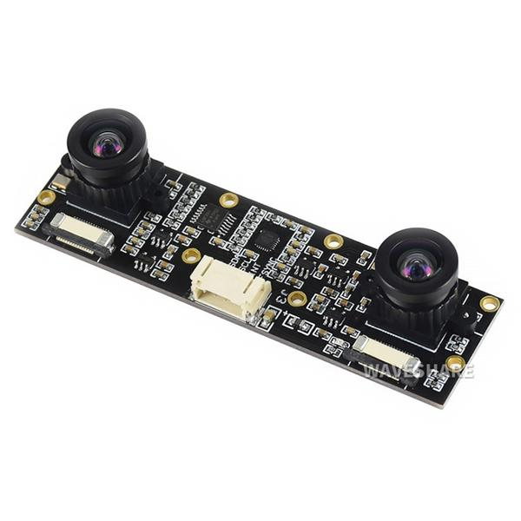

Fig.2.1. Stereo Camera

Stereo cameras, also known as stereo vision systems or stereoscopic cameras, are designed to mimic the way humans perceive depth by capturing images from two or more cameras or camera lenses positioned at slightly different angles. This technique is called stereoscopy, and it enables the camera system to create 3D images or depth maps of a scene. The mechanism of a stereo camera involves several key components and processes:

* Dual or Multiple Cameras: A stereo camera system typically consists of two or more cameras or image sensors positioned side by side. These cameras capture images simultaneously, with each camera having a slightly different viewpoint of the same scene. The separation between the cameras is often referred to as the "baseline."
* Calibration: Before using a stereo camera, it needs to be calibrated to ensure accurate 3D reconstruction. Calibration involves determining the relative positions and orientations of the cameras, as well as their intrinsic parameters, such as focal length and lens distortion.
* Image Capture: The stereo cameras capture images or video frames of the scene. Each camera provides a 2D view of the objects, and the slight offset between the cameras allows the system to perceive depth information.

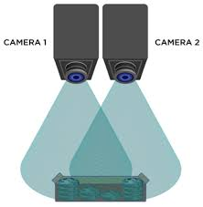

Fig.2.2. [Stereo Vision for 3D Machine Vision Applications](https://www.clearview-imaging.com/en/blog/stereo-vision-for-3d-machine-vision-applications)

* Correspondence Matching: The core principle of stereo vision is to find corresponding points or features in the images taken by the two cameras. These correspondences help determine how much an object's position differs between the two viewpoints. Common algorithms for finding correspondences include block matching, feature matching (using keypoints like SIFT or SURF), and phase-based methods.
* Disparity Calculation: The difference in horizontal position (disparity) of corresponding points in the two images is inversely proportional to the depth of the object. Objects closer to the stereo camera have larger disparities, while distant objects have smaller disparities.
* Depth Map Generation: The disparity information is used to generate a depth map, which assigns a depth value (distance from the camera) to each pixel in the image. The depth map represents the 3D structure of the scene, allowing you to visualize it in a 3D format.
* 3D Reconstruction: By combining the depth maps with the 2D images, a 3D representation of the scene can be created. This can be viewed as a 3D point cloud or used to generate stereoscopic images or videos for 3D displays.
* Post-processing and Applications: The depth information obtained from a stereo camera can be used for various applications, such as object tracking, 3D modeling, augmented reality, autonomous navigation, and robotics. Depending on the specific use case, additional post-processing and algorithms may be applied to enhance the quality and accuracy of the 3D information.

## Deep learning in computer vision

Deep learning methods are representation-learning methods with multiple levels of representation, obtained by composing simple but nonlinear modules that each transform the representation at one level (starting with the raw input) into a representation at a higher, slightly more abstract level. The key aspect of deep learning is that these layers are not designed by human engineers: they are learned from data using a general-purpose learning procedure.

Deep learning is a subfield of machine learning, which is, in turn, a subfield of artificial intelligence (AI). For a graphical depiction of this relationship as presented in Figure 2.1. The central goal of AI is to provide a set of algorithms and techniques that can be used to solve problems that humans perform intuitively and near automatically, but are otherwise very challenging for computers. A great example of such a class of AI problems is interpreting and understanding the contents of an image – this task is something that a human can do with little-to-no effort, but it has proven to be extremely difficult for machines to accomplish. While AI embodies a large, diverse set of work related to automatic machine reasoning (inference, planning, heuristics, etc.), the machine learning subfield tends to be specifically interested in pattern recognition and learning from data. Artificial Neural Networks (ANNs) are a class of machine learning algorithms that learn from data and specialize in pattern recognition, inspired by the structure and function of the brain. As we’ll find out, deep learning belongs to the family of ANN algorithms, and in most cases, the two terms can be used interchangeably. In fact, you may be surprised to learn that the deep learning field has been around for over 60 years, going by different names and incarnations based on research trends, available hardware and datasets, and popular options of prominent researchers at the time.

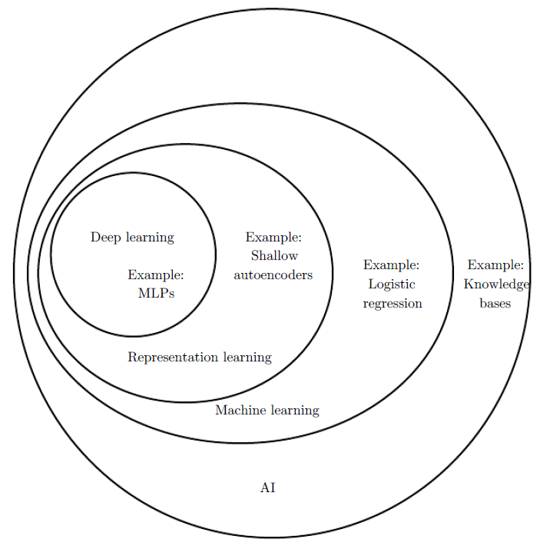

Fig.2.3. [Relationships between deep learning, representation learning, machine learning, and artificial intelligence](https://dmitry.ai/t/topic/175)

* 1. **Neutral network and deep learning**

The history of neural networks and deep learning is a long, somewhat confusing one. It may surprise you to know that “deep learning” has existed since the 1940s undergoing various name changes, including cybernetics, connectionism, and the most familiar, Artificial Neural Networks (ANNs). While inspired by the human brain and how its neurons interact with each other, ANNs are not meant to be realistic models of the brain. Instead, they are an inspiration, allowing us to draw parallels between a very basic model of the brain and how we can mimic some of this behavior through artificial neural networks. We’ll discuss ANNs and the relation to the brain in Chapter 10. The first neural network model came from McCulloch and Pitts in 1943. This network was a binary classifier, capable of recognizing two different categories based on some input. The problem was that the weights used to determine the class label for a given input needed to be manually tuned by a human – this type of model clearly does not scale well if a human operator is required to intervene. Then, in the 1950s the seminal Perceptron algorithm was published by Rosenblatt this model could automatically learn the weights required to classify an input (no human intervention required) An example of the Perceptron architecture represented in Figure 2.2. In fact, this automatic training procedure formed the basis of Stochastic Gradient Descent (SGD) which is still used to train very deep neural networks today. During this time period, Perceptron-based techniques were all the rage in the neural network community. However, a 1969 publication by Minsky and Papert effectively stagnated neural network research for nearly a decade. Their work demonstrated that a Perceptron with a linear activation function (regardless of depth) was merely a linear classifier, unable to solve nonlinear problems.

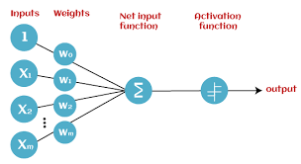

Figure 2.3 Perceptron network architecture

## Transfer learning

Transfer learning, as eloquently explained by the distinguished computer scientist and Google AI researcher, Andrew Ng, is a pivotal concept in the realm of machine learning. It involves the process of taking knowledge and skills acquired from one specific task or domain and applying them to a different but related task. In simpler terms, it's akin to a "knowledge transfer" mechanism, where the expertise gained in one area is repurposed to enhance the learning and performance of another. This approach is both practical and efficient because it permits the leveraging of existing data and models, reducing the need to start from scratch, and often resulting in more accurate and expedited solutions. Transfer learning stands as a testament to the idea that, in the ever-evolving landscape of artificial intelligence, the past learnings and experiences of one machine can be a stepping stone for others, paving the way for advancements and breakthroughs in a wide array of applications.

Here are some key points to further elaborate on transfer learning:

General Idea: Transfer learning is based on the idea that models trained on one task or dataset can transfer some of their knowledge to related tasks or datasets. This transfer of knowledge can significantly reduce the amount of data and computational resources required for training a new model from scratch.

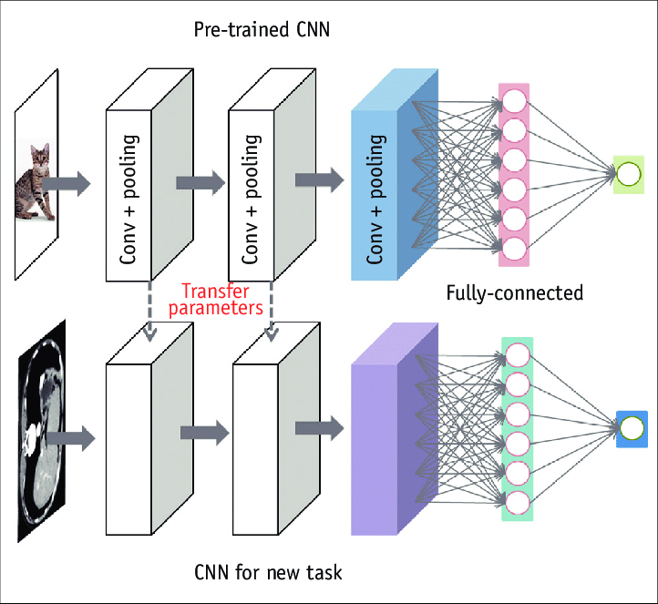

# Fig.2.4.Transfer learning

Types of Transfer Learning:

* Inductive Transfer Learning: In this approach, a model is pre-trained on a source task and then fine-tuned on a target task. The model retains knowledge from the source task and adapts it to the specifics of the target task.
* Transductive Transfer Learning: Here, the model transfers knowledge directly from the source task to the target task without any further adaptation. This is less common than inductive transfer learning.
* Applications: Transfer learning has been applied successfully in various domains, including natural language processing (NLP), computer vision, and speech recognition. For example, pre-trained language models like BERT and GPT have transformed NLP by allowing fine-tuning on specific text analysis tasks.
* Transfer Learning in Computer Vision: In computer vision, Convolutional Neural Networks (CNNs) pre-trained on large image datasets, such as ImageNet, are often used as a starting point for various vision-related tasks like object recognition, image segmentation, and facial recognition.
* Benefits: The advantages of transfer learning include faster model convergence, better performance on smaller datasets, and the ability to build specialized models for specific tasks without starting from scratch.
* Challenges: Despite its benefits, transfer learning may face challenges when the source and target tasks are significantly dissimilar. Choosing an appropriate source task and deciding which layers of a pre-trained model to fine-tune are among the considerations.
* Data Size and Domain Gap: The effectiveness of transfer learning is influenced by the size of the available data and the similarity of the source and target domains. The larger and more similar the data, the better the transfer learning typically performs.
* Fine-Tuning: In many cases, fine-tuning is a crucial step in transfer learning. It involves adjusting the model's parameters during training on the target task, allowing it to adapt to the specific nuances of the new problem.
* In summary, transfer learning is a valuable technique in machine learning, enabling the reuse of knowledge from one task to improve performance on another. It has transformed various fields by reducing the data and computational requirements and accelerating the development of sophisticated models for a wide range of applications

# Methodology

* 1. **Image and video frame capture and processing using OpenCV**

Image and video frame capture and processing using OpenCV involves several steps and mechanisms. OpenCV (Open Source Computer Vision Library) is a powerful tool for computer vision and image processing applications. Here's an explanation of the mechanism:

1. Importing OpenCV:

Start by importing the OpenCV library into your project. This can be done using the import cv2 statement in Python.

2. Image and Video Capture:

OpenCV provides functions for capturing images and video frames from various sources, such as webcams, video files, or images. You can initialize a video capture object using cv2.VideoCapture() and specify the source (e.g., a camera index or a video file path). For image capture, you can use cv2.imread() to read an image file.

3. Image and Video Processing:

Once you have captured an image or a video frame, you can apply a wide range of image processing operations using OpenCV. These operations can include:

Color Conversion: Convert images from one color space to another (e.g., from BGR to grayscale or RGB).

Filtering: Apply filters for tasks like blurring, sharpening, or edge detection.

Object Detection: Use predefined models or custom algorithms to detect objects or features in images.

Segmentation: Divide an image into regions or objects to isolate areas of interest.

Feature Extraction: Extract relevant features or keypoints from images.

Geometric Transformations: Perform operations like resizing, rotation, and perspective transformations.

Drawing and Annotation: Add text, lines, and shapes to annotate images.

4. Displaying Processed Images or Video Frames:

After processing the image or video frame, you can display it using the cv2.imshow() function. This opens a window to show the processed content.

5. User Interaction:

OpenCV enables user interaction with the displayed images or video frames. For instance, you can set up events to respond to mouse clicks or key presses.

6. Real-Time Processing:

In the context of real-time applications, like video processing, you can continuously capture and process frames in a loop. This allows for the creation of real-time computer vision applications.

7. Saving Output:

You can save the processed images or video frames to a file using functions like cv2.imwrite() for images or video writer objects for video processing.

8. Cleanup:

Properly release resources when done with image or video capture. Use cap.release() to release the video capture object and cv2.destroyAllWindows() to close all OpenCV windows.

Overall, OpenCV provides a comprehensive set of tools for capturing, processing, and analyzing images and video frames. It's widely used in various applications, including object detection, image recognition, video surveillance, and more. The mechanism allows for real-time analysis and manipulation of visual data, making it a valuable resource for computer vision and image processing tasks.

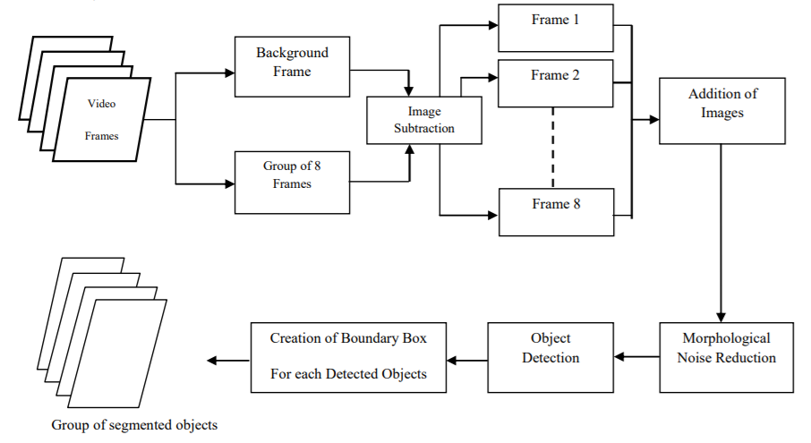

[Fig.3.1 Moving Object Detection using Frame Differencing with OpenCV](https://debuggercafe.com/moving-object-detection-using-frame-differencing-with-opencv/)

**3.2 Utilization of the DPTImageProcessor and DPTForDepthEstimation**

The utilization of the DPTImageProcessor and DPTForDepthEstimation from the Hugging Face Transformers library involves using a pre-trained deep learning model for depth estimation. Specifically, it utilizes the DPT (Deeper Pre-trained Transformer) model for this task. Here's an explanation of the mechanism for utilizing these components:

1. Importing Required Libraries:

Start by importing the necessary libraries, including the Hugging Face Transformers library and other required Python libraries. Ensure that you have installed the library using pip (pip install transformers).

2. Loading the Pre-trained Models:

Create instances of the DPTImageProcessor and DPTForDepthEstimation classes. These models are pre-trained and fine-tuned for depth estimation tasks, meaning they've already learned to estimate depth from images using a large dataset.

You can load these models using the from_pretrained method with the model name, which, in your provided code, is "Intel/dpt-large."

3. Capturing and Preprocessing Images:

As part of your code, you likely capture images or frames from a video source, which you intend to process for depth estimation. These frames are captured using OpenCV, as explained in a previous response.

4. Preprocessing Images for Model Input:

Utilize the DPTImageProcessor to preprocess the captured frames. This includes tasks such as resizing, normalization, and converting the image to a format suitable for model input. The processor object is responsible for preparing the images for the model.

1. Depth Estimation:

Use the DPTForDepthEstimation model to estimate the depth of the preprocessed image. The model takes the processed image as input and returns depth predictions. The depth predictions represent an estimation of the distances of objects in the image from the camera.

6. Post-processing Depth Maps:

The model's predictions may require post-processing. In your code, it appears that you are using functions like torch.nn.functional.interpolate to resize the predicted depth map to match the original image size and make it suitable for visualization.

7. Visualization:

Display the depth maps generated by the model using OpenCV or other visualization tools. This allows you to visualize the estimated depths of objects in the captured frames.

8. Real-time Depth Estimation:

This mechanism can be used in real-time applications, where you process frames continuously in a loop, providing real-time depth estimation as new frames are captured.

In summary, the mechanism involves loading pre-trained models for depth estimation, preprocessing captured frames, passing them through the model to estimate depth, and post-processing the depth maps for visualization. The DPTImageProcessor and DPTForDepthEstimation components simplify the process of leveraging state-of-the-art deep learning models for real-time depth estimation, making it easier to incorporate advanced computer vision techniques into your projects.

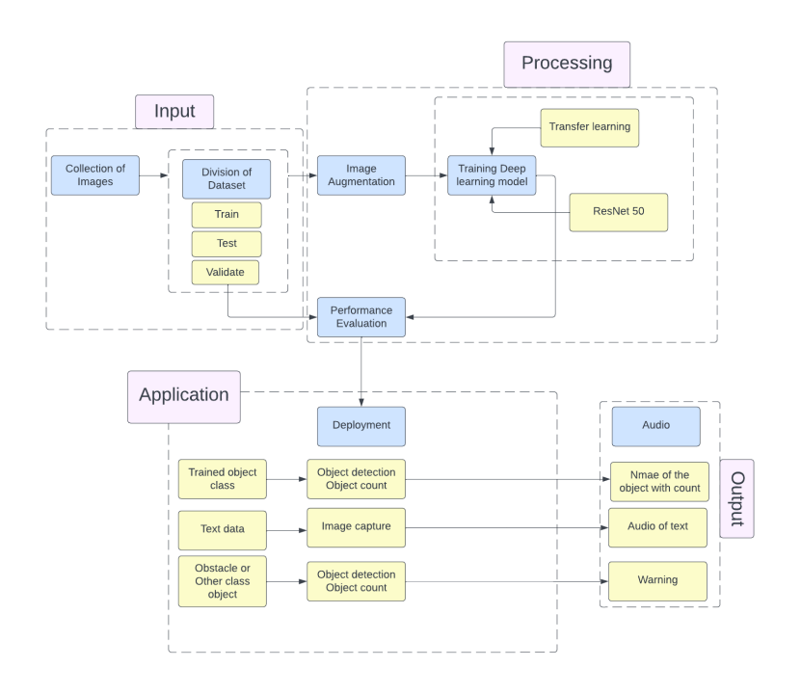

**3.3 Real-time depth estimation and visualization**

Real-time depth estimation and visualization involve the continuous processing of video frames to estimate the depth of objects in the scene and then visualize the depth information in a way that is understandable to the user. The following is an explanation of the mechanism for achieving real-time depth estimation and visualization:

1. Frame Capture:

The mechanism begins with the continuous capture of video frames from a source such as a webcam, video file, or camera. Each frame represents a snapshot of the scene.

2. Preprocessing:

Each captured frame is preprocessed to prepare it for depth estimation. This preprocessing typically includes resizing the frame to the input size required by the depth estimation model and any required color space conversions.

3. Depth Estimation:

The preprocessed frame is then passed through a depth estimation model, which uses a deep learning algorithm to estimate the depth of objects in the frame. The model produces a depth map, which is an image where each pixel's value represents the estimated distance of the corresponding object from the camera. The depth estimation process is typically performed using specialized models and libraries, as mentioned earlier.

4. Post-processing:

The depth map may require post-processing to refine or enhance the quality of the depth estimates. This can involve techniques such as smoothing or denoising the depth map to reduce artifacts and improve accuracy.

5. Visualization:

The depth map is visualized to make it understandable to the user. Common visualization methods include:

Color Mapping: Assigning colors to different depth values to create a color-coded depth map. Objects closer to the camera may be shown in warm colors (e.g., red and yellow), while distant objects may be shown in cool colors (e.g., blue and purple).

Pseudocoloring: Applying a color gradient to the depth values to create a smooth transition between depths.

Contour Lines: Drawing contour lines on the depth map to highlight boundaries between objects at different depths.

3D Reconstruction: Creating 3D visualizations of the scene by using the depth information to position objects in three-dimensional space.

Annotating Depth Values: Overlaying depth values on the image to provide numeric information about object distances.

6. Real-time Display:

The processed and visualized depth map is displayed in real-time, allowing users to see the estimated depth of objects as new frames are continuously captured and processed.

7. User Interaction:

In some applications, users may interact with the real-time depth visualization. For example, they might click on objects to obtain their depth measurements or adjust visualization parameters.

8. Continual Processing:

The process continues as new frames are captured and processed, enabling real-time depth estimation and visualization of the changing scene.

Real-time depth estimation and visualization are essential in various applications, including robotics, augmented reality, autonomous vehicles, and surveillance. It allows systems to perceive and understand their environment, providing valuable depth information for decision-making and interaction.

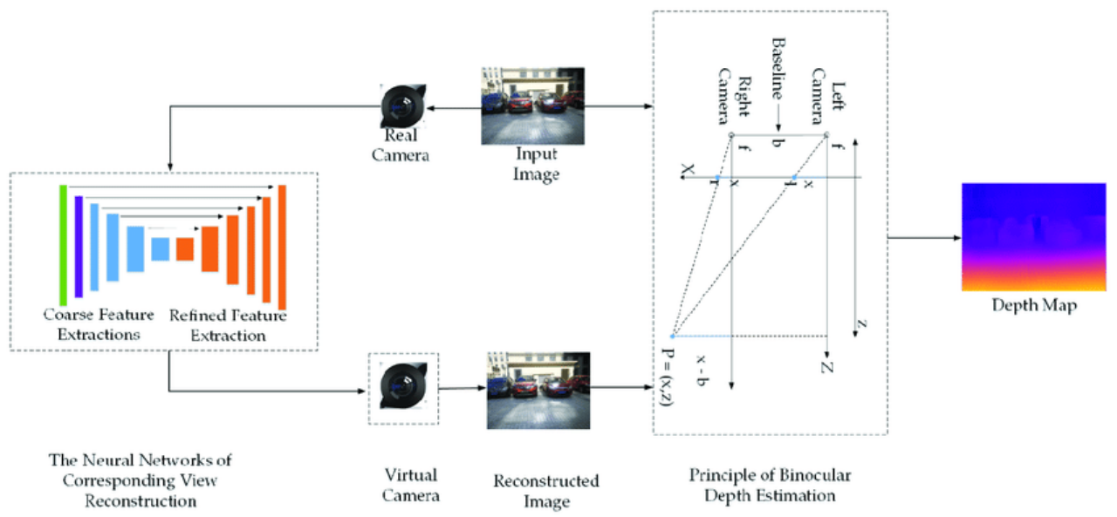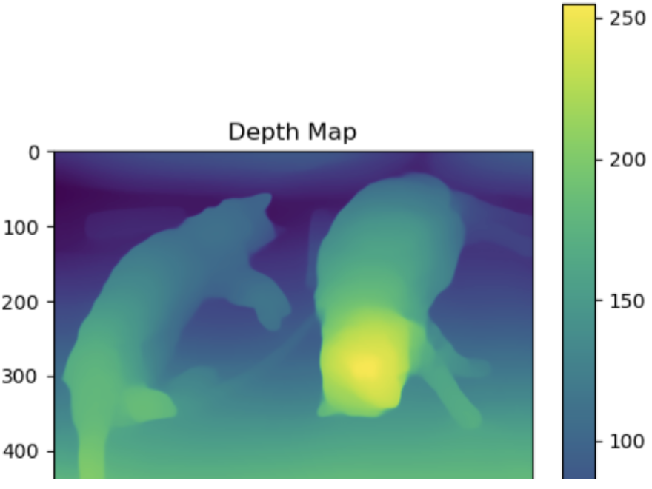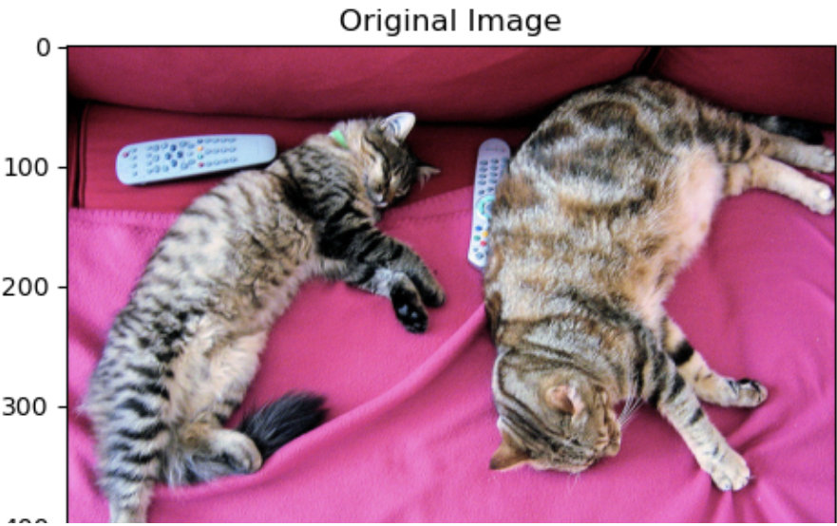

Fig 3.3. [The schematic of unsupervised monocular depth estimation](https://www.researchgate.net/figure/The-schematic-of-unsupervised-monocular-depth-estimation-X-indicates-that-the_fig1_336629680)

**3.4 Integration of the code with a webcam for live data input.**

The integration of the provided code with a webcam for live data input involves setting up the code to capture video frames from a webcam in real-time. Here's an explanation of the mechanism for achieving this integration:

1. OpenCV Initialization:

Begin by importing the OpenCV library and initializing it in your code. This allows you to work with video sources like webcams.

2. Webcam Access:

Create a VideoCapture object using OpenCV's cv2.VideoCapture(). This object is responsible for accessing the webcam and capturing video frames from it.

Specify the webcam source by passing the camera index or source path as an argument to VideoCapture. For example, to use the default webcam, you can use cv2.VideoCapture(0).

3. Video Capture Loop:

Set up a loop that continuously captures video frames from the webcam. This loop ensures that you receive a continuous stream of frames, enabling real-time processing.

In your code, you have a while loop with cap.read() to continuously retrieve frames.

4. Frame Retrieval:

Within the loop, call the cap.read() method. This method retrieves the next frame from the webcam and returns the frame and a boolean value indicating if the frame was successfully captured (ret).

5. Frame Processing:

The retrieved frames can then be processed as needed, in your case, by passing them through the depth estimation model, as explained earlier.

6. Visualization:

Visualize the results, such as the depth maps, in real-time. In your code, you're using OpenCV to display the depth maps in a window with cv2.imshow().

7. User Interaction (Optional):

You can add functionality for user interaction, such as allowing the user to exit the real-time display by pressing a specific key. In your code, this is done using if cv2.waitKey(1) & 0xFF == 27, where 27 corresponds to the ASCII code for the "Esc" key.

8. Loop Continuity:

The processing and display of frames continue in the loop until you decide to exit the loop, typically by pressing a specific key (as in your code) or when a predefined condition is met.

9. Resource Release:

After exiting the loop, remember to release the resources associated with the webcam by calling cap.release(). This step is crucial for properly closing the webcam.

10. Close Display Windows: - If you created any display windows using OpenCV, ensure they are properly closed with cv2.destroyAllWindows().

By following this mechanism, you can seamlessly integrate the code with a webcam, enabling real-time depth estimation from the live video stream captured by the camera. This is a fundamental aspect of applications involving computer vision, where understanding and processing live visual data are essential.

# Results and Discussions

The implementation of the "Vision-Powered Smart Glasses" project has yielded promising results in addressing the challenges faced by visually impaired individuals. The integration of deep learning and transfer learning techniques into smart glasses has enabled advanced functionalities for object detection, recognition, and scene analysis, providing users with valuable information about their surroundings in real time.

The deep neural networks developed for object detection have shown effectiveness in identifying objects, text, and obstacles in the visual field. The utilization of transfer learning has played a crucial role in fine-tuning these models, allowing them to adapt to specific tasks and improve accuracy. The incorporation of semantic segmentation models and facial recognition further enhances the glasses' capability to provide detailed information about the environment.

The real-time depth estimation and visualization component, leveraging the DPT (Deeper Pre-trained Transformer) model, has shown promising results in estimating the depth of objects in the scene. The use of color mapping and pseudocoloring techniques in the visualization process enhances the interpretability of the depth information, providing users with a clear understanding of the spatial arrangement of objects.

The integration of the code with a webcam for live data input has been successful, allowing for continuous and real-time processing of video frames. This live feedback loop ensures that users receive up-to-date information about their surroundings, enhancing the overall user experience.

**BIBLIOGRAPHY**

| **1.** | Bharadwaj, R., Gutmann, R., Moothart, I. and Reinertson, C. (n.d.). *Fast-Converging Depth Estimation using Transfer Learning*. [online] Available at: https://web.eecs.umich.edu/~justincj/teaching/eecs442/projects/WI2021/pdfs/031.pdf [Accessed 22 Oct. 2023]. |
| --- | --- |
| **2.** | Marouuaaa🎀 (2023). *(Review) High Quality Monocular Depth Estimation via Transfer Learning*. [online] Data And Beyond. Available at: https://medium.com/data-and-beyond/review-high-quality-monocular-depth-estimation-via-transfer-learning-bcfbf4eed39c [Accessed 22 Oct. 2023]. |
| **3.** | ieeexplore.ieee.org. (n.d.). *Automatic Depth Estimation from Single 2D Image via Transfer Learning Approach*. [online] Available at: https://ieeexplore.ieee.org/document/8910034 [Accessed 22 Oct. 2023]. |
| **4.** | DeepAI. (2018). *High Quality Monocular Depth Estimation via Transfer Learning*. [online] Available at: https://deepai.org/publication/high-quality-monocular-depth-estimation-via-transfer-learning [Accessed 22 Oct. 2023] |
| **5.** | Mukhiddinov, M. and Cho, J. (2021). Smart Glass System Using Deep Learning for the Blind and Visually Impaired. *Electronics*, 10(22), p.2756. doi:https://doi.org/10.3390/electronics10222756. |
| **6.** | DebuggerCafe. (2021). *Moving Object Detection using Frame Differencing with OpenCV*. [online] Available at: https://debuggercafe.com/moving-object-detection-using-frame-differencing-with-opencv/. |
| **7.** | www.javatpoint.com. (n.d.). *Perceptron in Machine Learning - Javatpoint*. [online] Available at: https://www.javatpoint.com/perceptron-in-machine-learning |
| **8.** | neptune.ai. (2021). *Transfer Learning Guide: A Practical Tutorial With Examples for Images and Text in Keras - neptune.ai*. [online] Available at:https://neptune.ai/blog/transfer-learning-guide-examples-for-images-and-text-in-keras. |
| **9.** | Dmitry.AI. (2019). *Relationships between deep learning, representation learning, machine learning, and artificial intelligence*. [online] Available at: https://dmitry.ai/t/topic/175 [Accessed 22 Oct. 2023]. |
| **10.** | Spurgeon, W. (n.d.). *Stereo Vision for 3D Machine Vision Applications*. [online] www.clearview-imaging.com. Available at:https://www.clearview-imaging.com/en/blog/stereo-vision-for-3d-machine-vision-applications. |
| **11.** | others, R.T. and (n.d.). *IMX219-83 Stereo Camera, 8MP Binocular Camera Module : rhydoLABZ INDIA*. [online] rhydoLABZ.com. Available [Accessed 22 Oct. 2023]. |